Parent Information night

# The GATE Institute Fall 2019

is the GATE institute the best option for my gifted child?

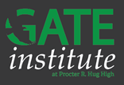While many choices are available, The GATE Institute offers a unique opportunity specifically designed for gifted and talented students. The innovative Institute offers accelerated pathways, GT specific courses, AP Capstone diploma, streamlined dual-enrollment process, Health Science Signature Academy & medical pathways, early access to Advanced Placement courses, and more– all inside a comprehensive high school campus, with as many clubs and extra-curricular activities a student could want!

presenting near you!

|  |  |  |  |
| --- | --- | --- | --- |
| **LOCATION** | **EVENT** | **TIME** | **DATE** |
| Clayton Middle School | * Booth @ Passport to HS Success * Special Session @ Room A101 | * 5:30-7:00 Drop In * 6:30 | November 12 |
| Dilworth Middle School | * Booth @ Passport to HS Success | * 5:30-7:00 Drop In | November 14 |
| Sky Ranch Middle School | * Booth @ Passport to HS Success * Special Session @ Room TBA | * 5:30-7:00 Drop In * 6:30 | November 19 |
| Pine Middle School | * Booth @ Passport to HS Success * Special Session @ Room 233 | * 5:30-7:00 Drop In * 6:30 | November 22 |
| Swope Middle School | * Special Session @ Room N-7 | * 5:30 | December 10 |

**New School @ Wildcreek**

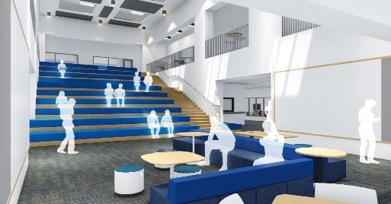

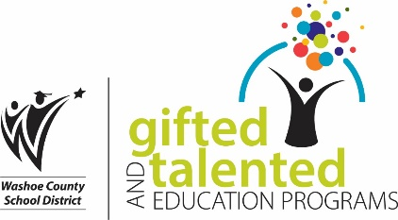

# the department of gate program office number: 775-861-4451 email: [giftedandtalented@washoeschools.net](mailto:giftedandtalented@washoeschools.net)